Chapter 15, Solution 38.

- 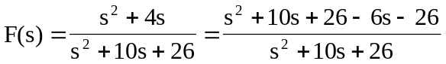
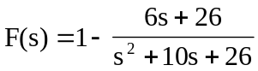
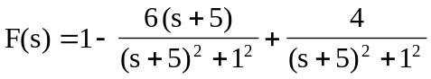

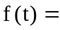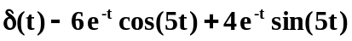

- 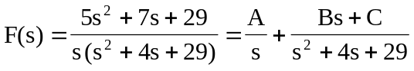

Equating coefficients :
 